**Session 22: DEPLOYING A SPARK APPLICATION**

**Assignment 22.2**

**Problem Statement**

Implement the below blog at your end and send the complete documentation. [https://docs.google.com/document/d/14YUd_wi-KJTBEqqtyoNtPMFeORjFU-_yId4hJ11q90o/edit](https://docs.google.com/document/d/14YUd_wi-KJTBEqqtyoNtPMFeORjFU-_yId4hJ11q90o/edit%20)

**Sentiment analysis on demonetization**

Let us find out the views of different people on the demonetization by analyzing the tweets from twitter. Here is the dataset where twitter tweets are gathered in CSV format. You can download the dataset from the below link

<https://drive.google.com/open?id=0ByJLBTmJojjzNkRsZWJiY1VGc28>

***val tweets = sc.textFile("/home/acadgild/hadoop/demonetization-tweets.csv").map(x =>x.split(",")).filter(x=>x.length>=2).map(x => (x(0).replaceAll("\"",""),x(1).replaceAll("\"","").toLowerCase)).map(x => (x._1,x._2.split(" "))).toDF("id","words")***

***tweets.registerTempTable("tweets")***

***val explode = spark.sql("select id as id,explode(words) as word from tweets").registerTempTable("tweet_word")***

***valafinn = sc.textFile("/home/acadgild/hadoop/AFINN.txt").map(x =>x.split("\t")).map(x => (x(0),x(1))).toDF("word","rating").registerTempTable("afinn")***

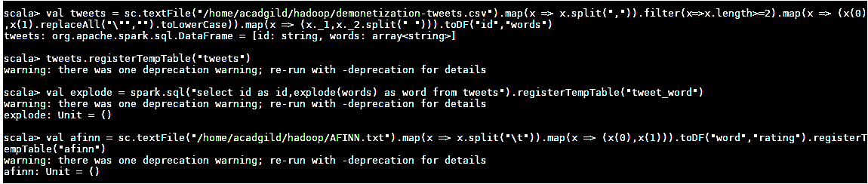

***val join = spark.sql("SELECT t.id,AVG(a.rating) as rating from tweet_wordt join afinna on t.word=a.word GROUP BY t.id ORDER BY rating desc").show***

**Output**

